

***(An Autonomous Institute)***

**Walchand College of Engineering, Sangli**

Department of Computer Science & Engineering

A Synopsis on

Uttar.Ai: AI-based question-solving and quiz-setting portal

***Third Year (Semester I) of***

**B. Tech in Computer Science & Engineering**

***Submitted by***

***Viraj Shrikant Patil (21510097)***

***Datta Naresh Gangji (21510027)***

***Jyotiraditya Bajirao Patil (21510087)***

***Under the Guidance of***

## Prof. Siddharaj Pujari

**Department of Computer Science & Engineering**

**2023-24**

# PROBLEM STATEMENT:

The project addresses the challenge of automating question recognition and answer generation from images, particularly in educational and informational contexts. Current methods need more efficiency and automation in processing questions extracted from images.

# ABSTRACT:

In an era characterized by the increasing integration of artificial intelligence into our daily lives, there exists a compelling opportunity to harness this transformative technology for educational and informational purposes. The project presented in this abstract introduces a pioneering web-based platform designed to streamline and enhance the way questions are extracted from images, answered accurately, categorized effectively, and ultimately utilized to create quizzes.

The core challenges this project seeks to address is the automation of question recognition and answer generation from images, a task that holds significant potential in various domains, including education, content creation, and knowledge management. Current methods often rely on manual processes, limiting efficiency and scalability. Our project endeavors to bridge this gap by harnessing cutting-edge artificial intelligence techniques and image processing algorithms.

Key components of this project include:

1. Image Processing for Question Extraction
2. AI-Based Question Answering
3. Categorization and Tagging
4. Quiz Generation

# INTRODUCTION:

In the modern age of technology, artificial intelligence (AI) has emerged as a transformative force, permeating various aspects of our lives. One area where AI holds immense potential is in the automation and augmentation of educational content creation and access. The project presented in this synopsis represents a pioneering step towards realizing this potential by seamlessly integrating AI into the process of recognizing and answering questions from images. This introduction sets the stage by providing context, motivation, and a clear understanding of the project's objectives.

The Context of AI in Education and Content Creation:

Education and knowledge dissemination have seen a remarkable shift towards digital platforms and technology-driven solutions. Online learning, e-books, and digital course materials are becoming increasingly prevalent. However, these advancements often lack the automation necessary to efficiently handle questions and answers within these contexts. Herein lies the opportunity for AI to play a transformative role.

Artificial intelligence is not just a buzzword; it is a technology with tangible capabilities. Machine learning, deep learning, and natural language processing have empowered AI systems to comprehend and respond to human language with remarkable accuracy. These capabilities are poised to revolutionize the way we interact with educational content, make learning more accessible, and facilitate content creation.

**The Motivation**:

The motivation behind this project stems from the recognition of the challenges and limitations associated with current methods of handling questions extracted from images. Manual transcription and categorization of questions are labor-intensive processes prone to errors. Additionally, there is a pressing need for more interactive and engaging educational content, which can be achieved through automated quiz generation.

The project's fundamental motivation is to automate these processes, making educational content creation more efficient and accessible. By harnessing AI's capabilities, we aim to empower educators, content creators, and learners alike with a tool that can transform images into valuable learning resources.

**Significance of the Project**:

The significance of this project extends beyond its technical components. It addresses a critical need in the educational and content creation sectors. It promotes accessibility, efficiency, and interactivity in learning materials. Furthermore, it aligns with the global trend of harnessing AI for education, providing a solution that can potentially benefit educators, students, and content creators worldwide.

# Literature Review\Related Work

| **Sr. No.** | **Method** | **Author** | **Advantages** | **Limitations** |
| --- | --- | --- | --- | --- |
| 1 | Machine Learning Model | Mostafazadeh et al. [1] | Achieved state-of-the-art results on a benchmark dataset of image-question pairs | Requires a large amount of training data. |
| 2 | Rule- based system | Narendra et al. [2] | Simple and efficient to implement | May not be able to generate all possible questions about an image. |
| 3 | Machine Learning Model | Bajaj et al. [3] | Achieved good results on a variety of tasks, including question generation, question answering, and sentiment analysis. | Requires a large amount of training data. |

**OBJECTIVES**

1. To use an image processing algorithm for accurate question extraction and implement an AI-based system for generating answers to extracted questions.
2. To create a robust categorization system to classify questions into relevant tags and topics and enable the generation of quizzes based on categorized questions.
3. To design a user-friendly interface to upload images and access the system's functionalities.

# SOFTWARE REQUIRED

1. Programming Languages: Python, JavaScript
2. Frameworks: Flask (for web development), TensorFlow, PyTorch (for AI components)
3. Libraries: OpenCV, NLTK, scikit-learn
4. Database: MySQL, MongoDB
5. Web Development Tools: HTML, CSS, JavaScript.

# OUTCOMES / DELIVERABLES

1. AI-based question extraction from the uploaded images and answer generation modules.
2. A quiz generation feature from the categorized dataset of question.

**METHODOLOGY**

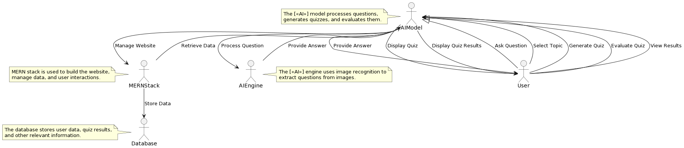UML Diagram:

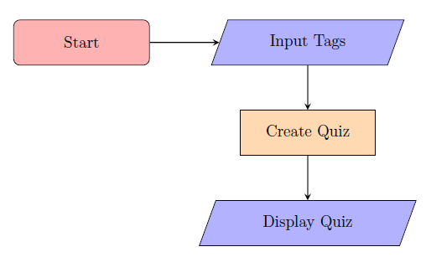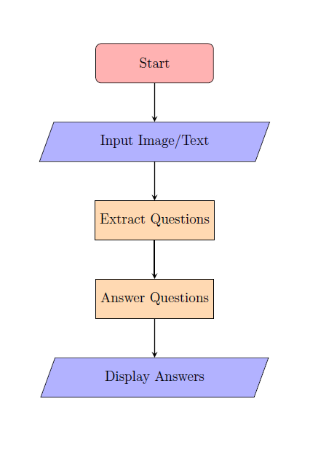Flow Diagram:

## Brief Explanation of Methodology:

The working of the question-solving feature is firstly it will be given with the input of image or text and the AI System will extract the question from the image using Optical Character Recognition (OCR) technique. After the extraction of the question the AI model will solve the extracted question using the dataset given and the final result is displayed.

The working of quiz-setting feature is user must give required inputs as the subject for which the test is to be set, the category of questions, the weightage of the questions, etc. The AI model will work on the same dataset which is generated while extracting the questions, all the questions extracted will be stored in database and can be used as dataset for quiz-setting. The AI model will analyze the questions and also the user inputs and generate a quiz accordingly.

# APPLICATIONS:

1. Educational institutions for automated question generation.
2. E-learning platforms for efficient content creation.
3. Content creators seeking to automate content generation.
4. Researchers interested in question-answering systems.
5. A wide range of industries and fields where automated question analysis can be beneficial.

# REFERENCES:

[1] Mostafazadeh, N., Lee, D., & Grauman, K. (2015). Learning to ask: Generating natural language questions from images. In Proceedings of the IEEE Conference on Computer Vision and Pattern Recognition (CVPR), 5125-5134.

[2] Narendra, V., & Kulkarni, S. (2013). Automatic question generation from images. In Proceedings of the International Conference on Intelligent Text Processing and Computational Linguistics (CICLing), 323-334.

[3] Bajaj, P., Sharma, V., & Sharma, A. (2020). A hybrid approach for generating natural language questions from images. In Proceedings of the IEEE Conference on Computer Vision and Pattern Recognition Workshops (CVPRW), 103-111.